Product Quality Metrics

🔹 Definition
# Source: Chatgpt (GPT-5-Standard) at [8/18/2025]
Product Quality Metrics are measures used to evaluate the quality of the software product itself, not the testing process.
They assess how well the product meets customer requirements, performance, reliability, and user satisfaction.
👉 In short: They answer the question – "How good is the product?"

🛠️ Key Product Quality Metrics

1. Defect Density
# Source: Chatgpt (GPT-5-Standard) at [8/18/2025]
- Description: Number of defects per unit size of the product (e.g., per 1,000 lines of code or per function point).
- Formula:
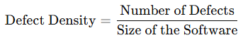
Defect Density=Number of DefectsSize of the Software\text{Defect Density} = \frac{\text{Number of Defects}}{\text{Size of the Software}}
- Example: 20 defects per 10,000 LOC = 0.002 defects per LOC.
📌 Insight: Lower defect density = better product quality.

2. Defect Severity Index (DSI)
# Source: Chatgpt (GPT-5-Standard) at [8/18/2025]
- Description: Measures overall impact of defects on the product.
- Formula:
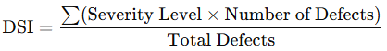
DSI=∑(Severity Level×Number of Defects)Total Defects\text{DSI} = \frac{\sum (\text{Severity Level} \times \text{Number of Defects})}{\text{Total Defects}}
- Example: If many critical defects exist → high DSI → poor quality.

3. Reliability (MTBF – Mean Time Between Failures)
# Source: Chatgpt (GPT-5-Standard) at [8/18/2025]
- Description: Average time the system operates without failure.
- Formula:
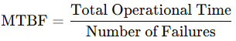
MTBF=Total Operational TimeNumber of Failures\text{MTBF} = \frac{\text{Total Operational Time}}{\text{Number of Failures}}
- Example: 500 hours / 5 failures = 100 hours MTBF.
📌 Insight: Higher MTBF = more reliable product.

4. Availability
# Source: Chatgpt (GPT-5-Standard) at [8/18/2025]
- Description: Percentage of time the system is available for use.
- Formula:
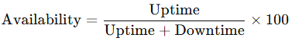
Availability=UptimeUptime + Downtime×100\text{Availability} = \frac{\text{Uptime}}{\text{Uptime + Downtime}} \times 100
- Example: 99.9% uptime = high availability (good for banking/telecom apps).

5. Maintainability
# Source: Chatgpt (GPT-5-Standard) at [8/18/2025]
- Description: How easily the software can be modified, debugged, or enhanced.
- Measured By: Average time to fix defects, code complexity metrics (Cyclomatic Complexity).

6. Usability
# Source: Chatgpt (GPT-5-Standard) at [8/18/2025]
- Description: How easy and intuitive the software is for end-users.
- Measured By:
  - User satisfaction surveys (SUS score).
  - Number of user errors while using the product.

7. Performance Efficiency
# Source: Chatgpt (GPT-5-Standard) at [8/18/2025]
- Description: How well the software performs under expected workload.
- Metrics: Response time, throughput, resource utilization.
- Example: API response < 200ms under 1,000 concurrent users.

8. Security Metrics
# Source: Chatgpt (GPT-5-Standard) at [8/18/2025]
- Description: Measure how secure the product is.
- Examples:
  - Number of vulnerabilities found.
  - Time taken to fix security flaws.
  - % of test cases passed in penetration testing.

📊 Example Summary (E-commerce Web App)
# Source: Chatgpt (GPT-5-Standard) at [8/18/2025]
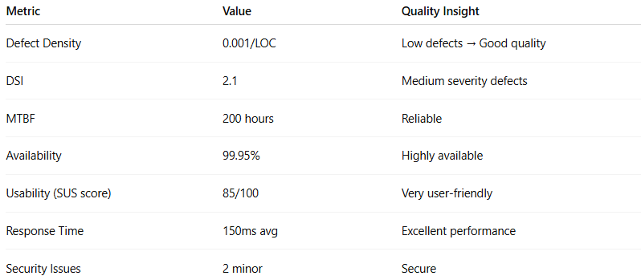
Metric | Value | Quality Insight
Defect Density | 0.001/LOC | Low defects → Good quality
DSI | 2.1 | Medium severity defects
MTBF | 200 hours | Reliable
Availability | 99.95% | Highly available
Usability (SUS score) | 85/100 | Very user-friendly
Response Time | 150ms avg | Excellent performance
Security Issues | 2 minor | Secure

✅ Why Product Quality Metrics Matter
# Source: Chatgpt (GPT-5-Standard) at [8/18/2025]
- Show customer satisfaction level.
- Ensure product is reliable, maintainable, and secure.
- Help compare quality between releases.
- Provide data for continuous improvement.

👉 In short:
Test Process Metrics = efficiency of testing process.
Product Quality Metrics = effectiveness & quality of the software product itself.

